The Geopolitics of 2014….and Beyond

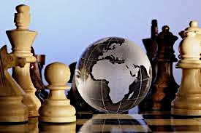

Learning Experiences
Niagara-on-the-Lake
April 29-May 2, 2014

The Geopolitics of 2014….and Beyond

Session | Page | Topic | Region
1 | 4 | The big picture – Major forces at play | China’s new assertiveness – a cause for concern?
2 | 13 | Economics and Geo-economics | Is Russia regaining its sphere of influence?
3 | 22 | The influence of demographics | Possible scenarios for Europe in 2014
4 | 31 | The geopolitics of energy | The United States in decline…again?
5 | 40 | Global terrorism - waxing or waning? | Can Middle East peace be advanced in 2014?
6 | 47 | Surveillance and Cybersecurity | Emerging players: Turkey, Nigeria, Colombia et al
7 | 57 | The evolution of global governance | What it all means for us
Contents

Session 1: The Major Forces At Play; The Rise of China

What is “geopolitics”?
- There are two complementary definitions:
  - The power relations between nation states. This is the more common usage, but is becoming somewhat dated because of the changing nature of power: many players with power today are not nation-states, but non-governmental organizations such as Amnesty, social movements such as environmentalism, social networks enabled through tools such as Facebook, and even “hyper-empowered” individuals such as Bill Gates.
  - The second, more classic but less common usage is the intersection between geography and politics – how geography influences and in some cases determines political outcomes. The situation in Ukraine is an example because Russia’s actions are driven by and enabled by geography.

- Another dimension of geopolitics is the “world order” within which this is taking place. The world order in the 19th and early 20th century was that of “balance of power” between competitive nations/empires: Britain, France, Germany and Russia. This competition was based on interests, not ideology, and broke down with WWI.

- After WWII a new world order emerged of two competing ideological blocks playing a global chess game, often with proxy wars. This ended with the collapse of the communism and the Soviet Union from 1989 to 1991.

- Two narratives emerged soon thereafter about the post-cold war world order:
  - The “end of history” proposition put forward by Francis Fukuyama, according to which the whole world would move towards liberal democracy.
  - The “clash of civilizations” proposition put forward by Samuel Huntingdon, according to which the major conflict in the world would not be between ideological systems, but between civilizations: Islam, the West, Orthodox, Han-Chinese, Hindu, African, Latin American and Japanese.
Do you see either of these two propositions as more persuasive in 2014, about 20 years after they were put forward?
Anaylzing Geopolitics in 2014

- The world order has shifted fundamentally away from unipolar U.S. leadership to a multi-polar world or, in the view of some, a non-polar world.

- The multi-polar world view is that the U.S., China, the EU, Russia, the Arab oil producers and the biggest emerging nations such as Brazil, Turkey, Indonesia and Mexico collectively all represent “poles” of power and are able to influence world events and that the world order is a balancing of the interests of these players, and that they can collectively make the key decisions and solve major problems.

- The alternative view is that there are no longer poles of power at all. In a complex world, nobody is able to manage the agenda, with competing countries, NGOs, supra-national organizations and various advocacy groups all making global decision-making by any smaller group of nation-states largely impossible.

Are we moving into an era of “chaos” without clear global leadership or will multilateral institutions take the place of major powers?

The Major Forces at Play

- Since the end of the cold war, international affairs have been largely been driven by several mega-forces:
  - Globalization: The opening up of markets, enabling trade in goods and increasingly services. This has resulted in a huge shift of income and wealth to emerging countries, particularly China
  - The Internet: The flattening of hierarchies, ubiquitous data, social movements, mobilization of forces for change – the Arab Spring is a prime example.
  - Radical Islam: Stimulated partially as a result of globalization, this has produced 9/11 and similar events. The “war on terror” response by the U.S., UK and some others has transformed international relations. China, Russia, parts of Africa and Europe are all susceptible to radical Islam.
  - Climate change: Still in the background as a geopolitical force, but will likely have a large and unpredictable influence
  - Energy: Possibly the biggest factor. Significant energy power is in the hands of countries who use it as a geopolitical tool: Saudi Arabia, Russia, Venezuela etc.
  - Demographic shifts: Population growth in Africa, Latin America and parts of Asia, and demographic decline in the West will tilt economic and political power
  - The evolution of “global governance” – a multilateral approach to dealing with the world’s issues – the UN, G-8, G-20, NATO, IMF, WTO and competing organizations such as the Shanghai Cooperation Organization, the Eurasian Customs Union and the Collective Security Treaty Organization dominated by Russia and China

Which of these is likely to most influence geopolitics in coming years?

The Impact of Demographics on global markets

The demographic shifts we are seeing are unique in history, ubiquitous, universal & divisive:
- 1st ageing is forcing us to make decisions about sensitive issues of entitlement rights and obligations of citizens versus the state at a difficult time due to the financial crisis.

- 2nd it is making us confront important intergenerational issues about equity, fairness, taxes and benefits at time when globally, children face high rates of unemployment and considerable economic uncertainty.

- it is driving a wedge between mostly fast ageing developed countries & younger and more populous emerging countries over international financial and monetary policies.

- Ageing will cause the working age population to slow down, stagnate or decline. Potential economic growth will be lower and real interest rates may stay lower. Ageing will probably have disinflationary consequences as experienced in Japan.

Do you agree that global markets are beginning to take a long term hit due to the dropping support, and rising dependency ratios?

China

How is China’s Rise Affecting the World?

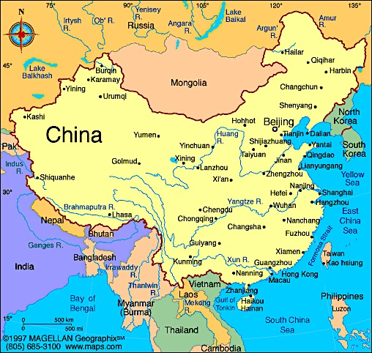

- In general, China’s rise has been benign and continues to be. China’s priority has been to modernize and build its economy. China has chosen largely to operate within the existing world order rather than to create some alternative. Although nominally communist, the country is not trying to export any ideology, and internally is increasingly capitalist, although a state-dominated version.

- A possible threat to the world order is that China is prepared to trade with and invest in countries without any consideration of their democratic or human rights behaviour. However, the West does the same despite espousing principles of human rights and freedom.

- The real threat is that China offers an example of autocracy that looks successful to other countries. Also, the rise of China provides poor developing countries with the ability to play the U.S. and China off against each other and gain economic advantage by doing so. This tends to keep autocrats in power.

Does the rise of China represent a threat to the “world order” in the sense that it will retard the progress of the world’s peoples to freedom and prosperity, or will it speed up the spread of prosperity?

Is China going to assert itself as a major power and will it in fact become a major power?

- China is still in the “catch up” phase of modernization, so its longer-term ability to compete as an advanced economy is unproven. China is still a lower-middle income country, although the size of its total economy in purchasing power parity terms will overcome that of the U.S. in the next 5-10 years.

- China’s economic expansion has been driven by its ability to mobilize a vast labour pool, enabling huge manufacturing exports, and the investment in huge infrastructure projects – roads, rail, ports, airports, dams etc.

- The country’s economic model has also been largely to use state-owned enterprises to control large swaths of the economy, without competition or transparency. Many believe large investments and debt will have to be written off, putting the financial system at risk.

- The Chinese government understand that to be sustainable the economic model has to shift to one of greater domestic consumption. Without this, the economy will likely run out of steam.

- Although China has examples of sophisticated technology and innovation such as Huawei, Alibaba and others, it still cannot remotely compete with the U.S. as an advanced economy.

- However, China is making massive investments in its education system and its infrastructure, including renewable energy, areas in which the U.S. lags. This leads some to believe that it will, over time, maybe 20-30 years, overtake the U.S. in its fundamental capacity to create prosperity.

- The open question is whether China’s centrally managed system can continue to move forward without political reform. China also faces ongoing challenges to its authority in its two large Western “provinces”, Xinjiang and Tibet, for different reasons. There is no evidence yet that this is a serious threat.

- China also has demographic issues. Its population is ageing rapidly, which means that its working age population will decline over time. Offsetting this is that there are still hundreds of millions of people moving to the cities and joining the labour force. China probably still has 20-30 years of labour force growth.

Will China be a long-term economic power or will it run out of steam?

- China has so far been careful not to assert itself too strongly geopolitically, to avoid the perception that it is trying to upset the world order or that it is competing with the U.S. for global power. However, this is changing in a number of ways.

- China and its neighbours. China is becoming increasingly assertive in its push to control its maritime access through the South and East China seas. This is a concern to Japan, The Philippines and Vietnam amongst others. At some point, there will be push back or alternatively China will totally dominate East Asia.

- China and Russia. At the moment these two powers live uneasily beside each other, but gradually, China is exerting large economic influence over Russia’s sparsely populated Far East. There is increasing speculation that China will eventually assert control over this region, if only because it has the population and economic clout to do so. On the other hand China is becoming the major customer for Russia energy, tying the two countries together economically.

- China and the United States. The new “great game” in geopolitics is between China and the U.S. The U.S. still controls the seas everywhere, but China is building a blue water navy, including aircraft carriers. Both are vying for influence in Africa and Central Asia. The U.S. still controls the Western Pacific, but this is likely to be challenged by China in the coming decade.

- China is also moving to reduce its dependence on sea lanes for trade. It is building an overland route for trade, energy and supply across Central Asia to the port of Gwadar in the Indian Ocean. It is also building natural gas pipelines from Turkmenistan on the Caspian Sea thousands of miles to Western China.

- China’s geopolitical moves are almost entirely to secure access to energy resources, its supply lines and its export routes. It is not taking action overtly to step into spaces that are prime areas of U.S. influence, such as Latin America or Europe. However, the real theatre of competition will be East Asia/Western Pacific, where China is challenging U.S. hegemony.

- It has the advantage of geography. The United States will be hard-pressed to match China’s ability to project power into East Asia. At present the U.S. has an advantage in that China is disliked and feared by many in the region, but China is doing all it can to overcome this, particularly with respect to South East Asian countries and South Korea. Japan is still a problem. As the country’s economies become more integrated with that of China, which is happening rapidly, political views will change.

- In summary, China is moving rapidly to protect and advance its interests. Its military is much smaller than that of the U.S. but it is strategically building military capacity.

Is China on track to compete with the U.S. geopolitically? Will this be a peaceful competition? Should we be worried that it won’t be?

Chinese Cyber-Espionage and Cyber-War Capability

- According to a 2013 Pentagon report to Congress: “China is using its computer network exploitation capability to support intelligence collection against the U.S. diplomatic, economic, and defense industrial base sectors,” the report said. “In 2012, numerous computer systems around the world, including those owned by the U.S. government, continued to be targeted for intrusions, some of which appear to be attributable directly to the Chinese government and military.”

- Why is Beijing willing to hack? China needs trade intelligence as it upgrades its economy and Chinese corporations go abroad. One key use of cyber espionage: Chinese oil and gas companies are secretly gathering data to help them win foreign acquisition deals, says Nigel Inkster, director of Transnational Threats and Political Risk at the International Institute for Strategic Studies in London. “It gives them an unprecedented capacity to collect huge volumes of information that in the past they might not have had access to,” says Inkster.

- The U.S. claims that at least 35 companies have been attacked. Reported cases include Google, Northrop Grumman, Symantec, Yahoo, Dow Chemical, and Adobe Systems. Cyber-espionage has been aimed at both commercial and military interests, especially areas in which China lags. Technology companies have claimed that China has sought out source code, along with general information on weapon systems, to develop the software that China needs in both its economic and military pursuits

- China has hit back, accusing the U.S. of gross hypocrisy in light of the Edward Snowden revelations.

- However, not only the U.S., but Canada, Australia and India have all accused China of Cyber attacks.

Are cyber-attacks by China a serious geopolitical risk or a “sideshow”?

Session 2: Economics. Russia and Central Asia

Capitalism and Inequality

I’m going to try and make the case that free market capitalism’s inevitable outcome, is worsening inequality, one of the biggest geopolitical risks of 2014 and beyond. I’ll ask you at the end of the case whether, and why, you agree or disagree with this case.

- First Thomas Piketty, a professor at the Paris School of Economics has written a new book, “Capital in the 21st Century,” described by one French newspaper as a political & theoretical bulldozer, which defies left & right orthodoxy

- Capitalism confronts both modern & modernizing countries with a dilemma: entrepreneurs become increasingly dominant over those who own only their own labour. While emerging economies can defeat this logic in the near term, in the long run, when pay-setters set their own pay, there’s no limit, unless confiscatory tax rates are imposed. Traditional liberal government policies on spending, taxation & regulation will fail to diminish inequality

- The rise in inequality reflects markets working precisely as they should, rather than markets free of government intervention distributing the fruits of economic progress among all people. The more perfect the capital market, the higher the rate of return on capital is in comparison to the rate of growth of the economy. The higher this ratio is, the greater inequality is.

- A growing divide between what bosses make in relation to their employees is a tendency showing absolutely no sign of slowing down, and we can be sure that it will continue. The middle classes, the results of a century-long fight for social justice and redistribution from growth, are fast disappearing. The 60yr period of growing equality in western nations, from WWI to the early 1970s:
- was unique & highly unlikely to be repeated
- an exception to the more deeply rooted pattern of growing inequality
- were the result of two WWs & the Great Depression

- Postwar saw huge gains in growth and productivity, with benefits shared with workers who had strong backing from the trade union movement

Do you agree free market capitalism’s inevitable outcome is worsening inequality, & if so why?

The influence of demographics

The second case is that the decline in the rate of growth of the economy since the 1970’s, perhaps due to demographics, ensures continuing investment in capital rather than in labour. I’ll ask at the end of the case if you agree.

- From 1914 to 1973 rates of economic growth exceeded after-tax rates of return on capital. The owners of capital, at the top of the pyramid of wealth & income, absorbed a series of devastating blows:
- Loss of credibility and authority as markets crashed
- Physical destruction of capital in Europe in WWI, WWII
- Raising of tax rates on high incomes to finance wars
- High rates of inflation eroding the assets of creditors
- Nationalization of major industries in England & France

- Since then, the rate of growth of the economy has declined, while the return on capital is rising to its pre-WWI levels. If the rate of return on capital remains permanently above the rate of growth of the economy, it changes the distribution of income in favour of capital, away from labour. Then personal income distribution will also get more unequal — which is what we have witnessed in the past 30 years.

- Piketty’s analysis explains the global growth of unemployed. The International Labour Organization, a UN agency, reported the number of unemployed grew by 5 M from 2012-2013, to around 202 M by the end of last yr. It is projected to grow to 215 M by 2018. According to a study from the London School of Economics, in 16 years we will have returned to the level of social inequality in the days of Queen Victoria (1837-1901).

- Daron Acemoglu, a more centrist economist at MIT, argues that current inequality is consistent with what Piketty says, but;
- It is also consistent with certain technological changes and discontinuities (or globalization) having created a surge in inequality which will then stabilize or even reverse in the next several decades
- It is also consistent with the dynamics of political power changing & this being a major contributor to the rise in inequality in advanced economies
- We may be seeing parts of several different trends underpinned by several different major shocks rather than the mean-reverting dynamics following the shocks that Piketty singles out.

Do you agree, the decline in the rate of growth of the economy since the 1970’s, perhaps due to demographics, ensures continuing investment in capital rather than in labour, & if so why?

The last case is that the only way to halt this process, as Piketty argues, is to impose a global progressive tax on wealth. I’ll ask at the end if you agree.

- The tax would be global to prevent the transfer of assets between countries. A global tax would restrict the concentration of wealth & limit the income flowing to capital

Piketty would impose an annual graduated tax on stocks and bonds, property and other assets, customarily not taxed until they are sold. He leaves open the rate and formula for distributing revenues

- Piketty’s wealth tax solution runs directly counter to the principles of contemporary American conservatives who advocate the opposite for public policies, ie:
- cutting top rates
- eliminating the estate tax

It would also run counter to the interests of those countries that have purposefully legislated low tax rates in order to attract investment. The very infeasibility of establishing a global wealth tax, serves to reinforce Piketty’s argument concerning the inevitability of increasing inequality.

- There are a host of far less ambitious actions that might help to ameliorate inequality:
- A tax on finance in the U.S., either the financial transactions tax or the financial activities tax advocated by the I.M.F.
- Reform of patent laws could serve both to limit the value of drug and other patents, and simultaneously lower consumer costs

- This inequality phenomenon is related to the suppression of wage growth, so policies in favour of broad-based wage growth are an antidote. The political economy is such that the political power to enact those taxes, also requires a mobilized citizenry and institutional power, such as a robust labour movement.
- Urgent action is needed. Piketty like other scholars raises significant questions about: how the global economic system will deal with robotics; the hollowing out of the job market; continuing outsourcing & global competition. He sees the developed world on a path to a degree of inequality that will reach levels likely to cause severe social disruption.

Do you agree the only way to halt this process is to impose a global progressive tax on wealth, & if so why?

Russia and Central Asia

Is Russia going to regain a position as a major geopolitical power?

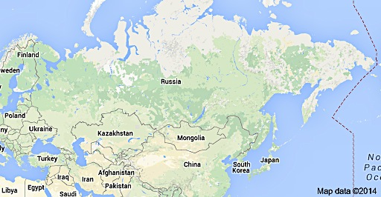

- Russia has been a power in one way or another at least since at least the 15th century. The country is one of the main nodes of the Orthodox religion, which it shares with the other Slavic people and Greece.

- Russia has for several centuries been an empire, expanding and contracting periodically. It reached a zenith in its power in the Soviet era, dominating Eurasia from East Germany to the Pacific. Obviously, its geographic domain has shrunk since then but is still massive.

- From a geopolitical point of view Russia has always sought to establish buffers around its core running from St Petersburg to the Black Sea and East to the Urals. Its buffers have been Ukraine, Belarus and Moldova in the West, the Caucasus region in the near South and Central Asia to the south of the Steppes. The loss of all these buffer states with the collapse of the Soviet Union has left Russia feeling vulnerable.

- Since 2000 when Putin came to power, Russia has been actively rebuilding its buffers:
  - It has effectively neutered Moldova, a very poor state anyway, by encouraging the independence of Transnistria.
  - It has tried to prevent Ukraine from aligning with the West, most recently annexing Crimea and making it clear that it would go further if necessary.
  - It has destabilized the South Caucasus countries of Azerbaijan and Georgia, encouraging the breakaway regions of Abkhazia, Nagorn-Karabakh and South Ossetia
  - It has established the Eurasian Economic Union along with Belarus and Kazakhstan and more recently Armenia, tying them tightly to Russia.
  - It has become a founding member of the Shanghai Cooperation Organization, along with China and several of the Central Asian Republics, ensuring joint security of Russia’s East and South.
  - It formed the Collective Security Treaty Organization, a military alliance, along with the Central Asian Republics and Armenia.
  - In summary, other than the three Baltic States, Russia has rebuilt much of its Soviet-era sphere of influence.
  - It is fair to say that Putin has, over 15 years, salvaged Russia from the ruins of the Soviet collapse.

- Not only has Putin pulled off a geopolitical coup; He has rebuilt Russian pride.

- Internally he has established himself as a largely unchallenged autocratic leader, willing to crush any opposition. He is able to pursue his agenda with minimal opposition or even questioning.

Some geopolitical experts regard Putin as by far the most powerful individual in the world. Do you agree?

What are Russia’s Geopolitical Strengths and Weaknesses?

- Russia has several major strengths that enhance its geopolitical position:
  - Its resources, particularly oil & gas. Russia has by far the largest natural gas reserves in the world. As of 2013 they were almost 50% greater than those of the next largest nation, Iran, and four times those of the U.S. They have the 8th largest oil reserves. They also have huge coal, timber, mineral and gold resources.
  - They have control over a large part of the natural gas supply to much of Europe
  - Its sheer size and strategic depth, as both Napoleon and Hitler found out, although the partial “loss” of Ukraine puts this in doubt.
  - Its access to the Arctic, Pacific and Mediterranean.
  - It’s strategic position in the Arctic is stronger than other Arctic countries, and it is well-positioned to take advantage of resources there.
  - It is a nuclear power
  - It has a large military capacity
  - It has veto power at the UN
  - It has an alliance with China
  - It is not afraid to pursue its interests, even if this is politically costly

- Russia also has a number of vulnerabilities:
  - The economy is dysfunctional. It is controlled by oligarchs and the state, and is overly dependent on resources. Manufacturing and innovation is far less robust than that in developed countries or even China.
  - Of critical importance, the oligarchs do not generally reinvest capital in Russia, except in resource projects.
  - Russia suffers from large-scale corruption.
  - Demographic decline. While not an immediate crisis, this is a serious longer term challenge. The population fell for several years, but is now growing slightly. The fertility rate at 1.7 is low although not as low as many European countries. Unless fertility increases and/or life expectancy increases significantly (and it has increased somewhat), Russia’s population will decline or possibly not decline but age rapidly. This will negatively affect its economic and military potential.
  - China, while an ally now, could become an adversary if it wishes to dominate Russia’s Far East economically. The disparity in population between the two countries in the Far East region is huge.
  - Russia is increasingly isolated from the Western developed countries, recently accentuated by the reaction to the Crimea annexation. This may reduce foreign investment.
  - Russia has an ongoing problem fighting Islamism in the Caucasus.

- Overall, Russia’s situation looks sustainable for the medium term at least. The longer term is more questionable, but Russia is succeeding in carving its own path.

Do you see Russia as a world power or as a second tier player?

Central Asia – What is its significance?

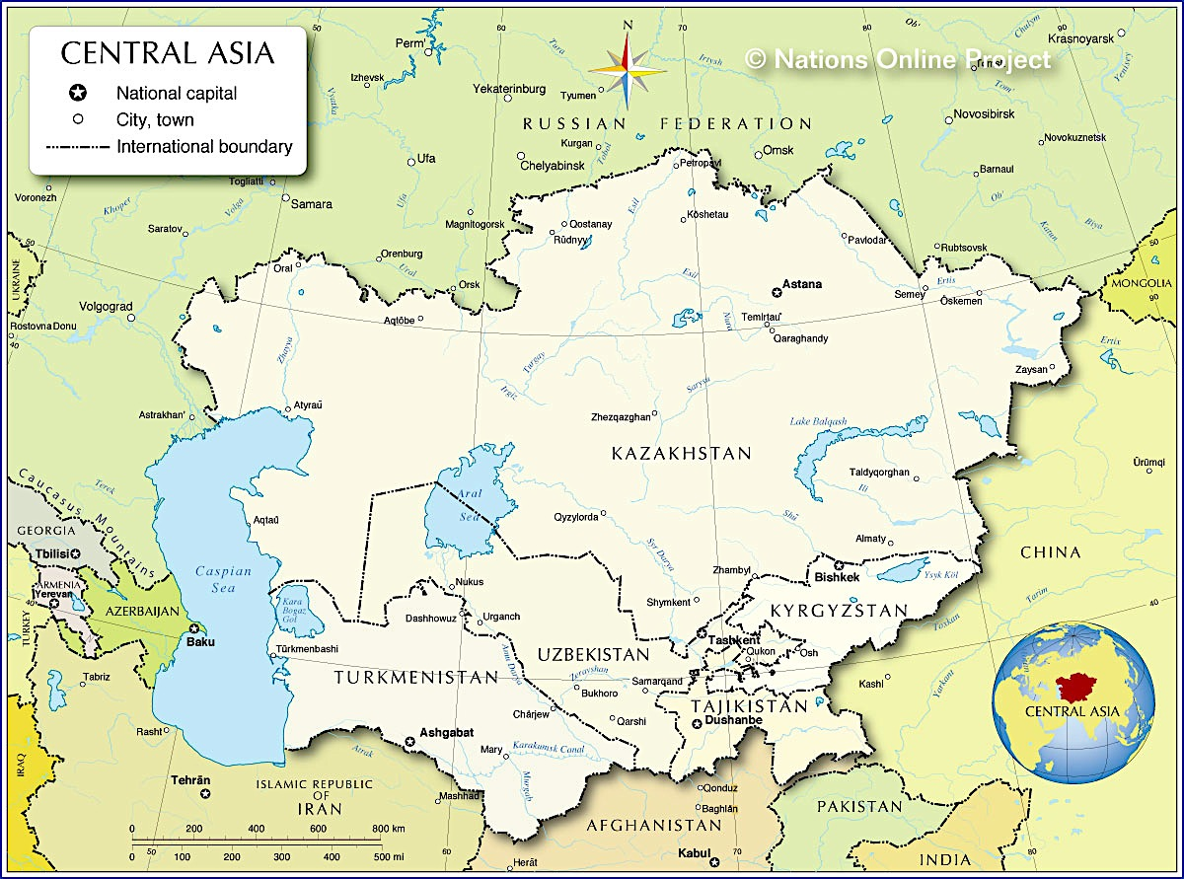

- Central Asia is five countries that were part of the Soviet Union: Kazakhstan, Kyrgyzstan, Tajikistan, Turkmenistan and Uzbekistan. They have a combined area larger than Western Europe and a population of about 66 million, the largest group of which is in Uzbekistan.

- Historically, these countries were the core of the Silk Road, a major trade route from China to Europe. Now they are poor countries with very low GDP (except Kazakhstan and to a more limited extent, Turkmenistan)

- Two of the countries, Kazakhstan and Turkmenistan have large-scale oil or gas deposits. Uzbekistan is one of the world’s major cotton producers.

- Geographically, these countries link Europe and East Asia and are important from three perspectives:
  - Economically, their resources are important to China and Europe.
  - Geopolitically, they are important to Russia, China and the U.S.. China sees them as an alternative overland link to sea lanes, to markets and supplies. Russia sees them as part of its “near abroad” and a key buffer region as well as an important market. Almost 10 million Russians live in the region, mostly in Kazakhstan. The United States has used them as a supply route into Afghanistan and sees them longer term as a stabilizer for Afghanistan.
  - From a security perspective, they are seen as a risk due to their large Muslim population, particularly by China, whose Islamic Xinjiang province borders the region. Both Russia and the U.S. also have security interests as these are potentially failed states and a staging ground for radical Islam.

- A new player is emerging as a power in Central Asia – Turkey. The Central Asian peoples are Turkic ethnically, and Turkey is proposing an alliance of Turkic peoples and is starting to have economic and cultural influence in the region. This is significant not only for Central Asia but for the emergence of Turkey as a power.

Is central Asia important in global affairs?

Session 3: The Influence of Demographics. Europe

Demographics and Geopolitics

The first of 3 cases deals with the fact that the emerging markets’ share of the world population is a major shift in the distribution and exercise of global power. I’ll ask you at the end of this first case whether, and why, you agree or disagree with this statement.

Some facts and predictions

- Today there are 31 countries with a median age over 40. By 2050, it’s predicted there’ll be 84, plus 15 where it’ll be over 50. This group of 100 countries includes half of Western Europe, Russia and all of Eastern Europe, Japan, Korea, and Taiwan. The US will be just over 40 and Canada is projected to be 45.3.

The big change in world population in the Western world now accounts for 17%, off the peak of nearly 25% in 1930. As population continues to grow, even though it’s slowing down, more emerging markets will account for 60% of world population. In 1950, there were 5 western countries in the top 10. Today there are 2 in the top 12, by 2050, there’ll be 1, the US, in the top 15.
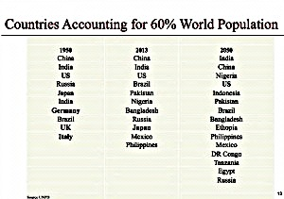
- Unlike small countries, those with large populations carry significant political & geopolitical weight, regardless of whether they are rich enough to join the OECD.

- Going forward, with whom will the BRICS & the MINTS (Mexico, Indonesia, Nigeria, Turkey) form alliances and on what basis? Without a benign global hegemony, how do we resolve tensions between globalization, which leads to progressive integration, and geopolitics, which leads to nationalism and security concerns?

- Everyone acknowledges the G20 had to be created to speak for more of the world than the old G7. It’s got Saudi Arabia and all the BRICS and MINTS except Nigeria. But it’s track record as an agent of change and coordination isn’t good.

- The main thing the 10 emerging markets in the G20 have in common is they’re not in the Western camp, and don’t feel subservient to the US, even though several depend on and identify with the US more than they might admit publicly.

- The blow to US economic prestige and political divisions has taken it out of the game of global leadership, for now at least.

Do you agree the emerging markets’ share of world population is a major shift in the distribution and exercise of global power?

The second case is that there is nothing inevitable or even probable about large populations becoming rich and powerful. I’ll ask at the end if you agree.

What does a rising middle class expect?
- People assume populous emerging markets will get a lot richer. If this happens as predicted in the next 20-30 years, the current distinction between developed and emerging markets may become irrelevant.

- But countries with large populations don’t become wealthy because they have a lot of people, any more than countries like Switzerland and those in Scandinavia with small populations are condemned to poverty or stagnation.

- Basically this comes down to what a rising middle class comes to expect, which is more accountable government & better, improved governance. The bigger the population, the more important this is.

How do countries become rich?
- Only about 35 countries, excluding small population oil producers, have become high-income nations (income per head greater than $30,000). This has a lot to do with their economic model to sustain productivity & the role played by robust & inclusive institutions in harnessing and organizing human capital.

- What most emerging countries have in common is the opportunity to exploit the ‘demographic dividend’. This is a phase during which child dependency is declining, and the working age population is expanding, but before the old age dependency ratio has really begun to shift. The ‘dividend’ is associated with strong trends in income & consumption growth, savings investment, & technical progress. For the majority of emerging markets, this dividend lies ahead.

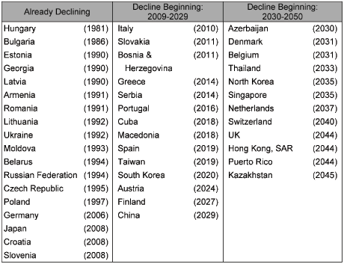

- But think about SE Asia and Latin America in the 1970s. They had comparable demographic structures, and if that were all that mattered they’d have the same economic level now. The reality could not be more different. Or more dramatic, look at the young and populous countries that experienced the Arab Spring. Rather than a source of prosperity, the demographic dividend can also go to waste or worse, without intervention to exploit it.

Do you agree that there is nothing inevitable, or even probable, about large populations becoming rich and powerful and if so why?
The third case is that the rise in population to 9.5B over the next 30 to 40 years, will make energy an even more key factor in critical geopolitical hotspots. I’ll ask at the end whether, you agree with this statement.

- Emerging markets and all but the least developed economies in the world will be in the same boat regarding rapid ageing, but not until around the 2030s for many countries, and even later for nations in Sub Sahara Africa. Emerging markets and developing countries will mostly have to adapt to ageing much faster than we have in the West.

- If you consider how long it took countries to double the share of their over-60s in their population from 7% to 14%, you get some startlingly different results. In France, it took over a century. In most other developed countries it has taken or is taking between 40-80 years, in the US, over 60 years. In many emerging countries the process is occurring in roughly 20 years with China in the lead.

- China’s over-60s population, for example, will grow from 144 million or 11% of the population, to 438 million or 31% by 2050. Some Chinese cities, for example, Shanghai, already have an age structure similar to that of Japan.

- Rapid ageing is a difficult economic issue, but having to build the social and income security infrastructure to deal with it in one third the time it took in the West and at significantly lower levels of income per head makes it much harder.

- With the bulk of the world’s population in Asia, having access to energy is going to be of utmost importance. Geopolitical hotspots then, are likely to be focused in the countries bordering the Straits of Hormuz, the Caspian Basin, the East and South China Seas and the energy-rich, and warming Arctic – where the strategic interests of the US, EU, China, and Russia all meet.

Do you agree that the rise in population to 9.5 Billion over the next 30 to 40 years will make energy an even more key factor of critical geopolitical hotspots?

What are likely scenarios for Europe in coming years?

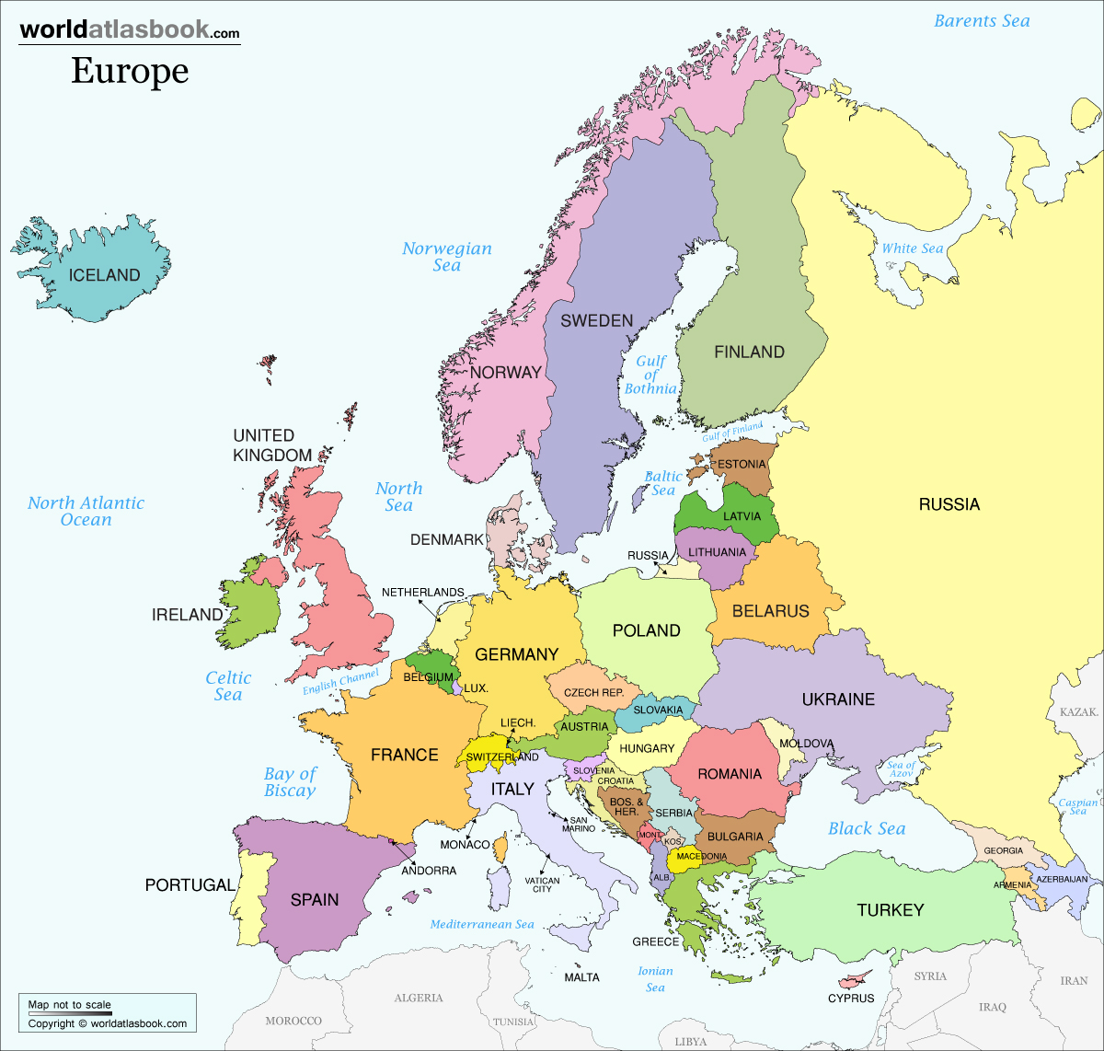

Europe today is troubled. There are several issues that need to be addressed to put the continent on a positive track:

- Unemployment is 10.8% overall in the EU, much higher in some countries such as Spain and Greece. Youth unemployment is 25%. GDP is barely growing.

- The financial crisis triggered by Greece is contained, but at a huge cost. It will take several years to heal the balance sheets of large banks and for several countries to get their finances in line. Annual deficits are still averaging over 3% of GDP and debt is 85% of GDP. Neither is sustainable, meaning more austerity and unemployment.

- There is an emerging sharp divide between the prosperity of Northern and Southern Europe, with a build up of resentment over austerity imposed on the southern countries.
- Nationalist, anti-immigrant, anti-EU parties are gaining ground in several countries, particularly the U.K. (UKIP), France (National Front), the Netherlands (Party for Freedom), Hungary (Jobbik) and Italy (Five Star). No-one is suggesting yet that these will result in the break-up of the EU, but these are troubling trends.

- The EU is largely unable to function as an integrated entity in economic and foreign policy matters. The EU, while hugely successful in having grown to include almost the whole continent, still cannot speak with one voice on key issues, such as demonstrated by the responses to the financial crisis and Ukraine.

- It is clear that the EU requires a period of self-examination as to what it really is and can become. Many commentators believe that the EU has overreached in the speed of its growth and the scope of its ambition to become more than an economic union but a true political union. Populations in many member countries have drawn the line at really giving up meaningful political sovereignty.

- Also, Europe is going into a period of demographic decline, with its population expected to decline from 740 million today, to about 600 million in 2100. The population will also age markedly, with the median age increasing to over 50 by 2050. Not everyone sees this as a problem, but geopolitical history says that it is.

- On the other hand, Europe offers, without doubt, the best quality of life in the world. Almost every survey on quality of life puts European countries and cities at the top. European countries also consistently top the list of innovators. On climate change, Europe is moving far faster than others to bring on renewable energy, which will give it a big competitive advantage in the coming decades.

- Finally, although much of Europe is integrated, there are still countries whose fate is “up for grabs”. Ukraine is an obvious one, but Belarus, Moldova, and the South Caucasus countries are all in uncomfortable “border zone” positions, between modern Europe and Russia.

Is Europe declining or is it going to emerge as the example to the rest of us of how to organize society?
Is Europe still a geopolitical player or is it’s very existence threatened?

“Who rules East Europe commands the Heartland; who rules the Heartland commands the World Island; who rules the World Island controls the world” – Sir Halford Mackinder, founder of the discipline of geopolitics.

- Only 100 years ago, power in the world was concentrated in Europe. The U.S. was just starting to be perceived as a power. Of course two world wars wiped out much of Europe’s power.

- However, today Europe still wields many levers of power:
  - Despite its current economic problems, it is wealthy
  - France and the UK have veto power at the UN (even if they should not)
  - Germany is the world’s leading export economy
  - Europe’s internal system of rivers give it a huge geographic advantage
  - Europe has strong access to the Arctic, Mediterranean and Atlantic
  - The EU, while flawed, enables Europe to take combined action.
  - Europe’s living standards and personal freedom are aspired to by the peoples of many nations (although not necessarily by their leaders)

- The EU has so far placed a high premium on the use of “soft power” to achieve significance. This means trade, culture and values, acting as an example based on Europe’s high quality of life. However, other than trade, the leaders of many developing countries do not aspire to Europe’s example, and have alternative models being presented to them from Russia and China, which are quite appealing to leaders anxious to retain power. The question is whether people can override their leaders.

- Europe’s colonization history works to its advantage. France, Britain and the Netherlands still wield significant clout in Africa and Asia despite the resentments from the colonial era. For example, France is able to act in the Central African Republic and Ivory Coast when the U.S. cannot. Britain is still respected in India, if not loved. When Burmese activists worked to achieve democracy, they did so out of London, as did the ANC for South Africa. In fact, it could be argued that London and Paris exert more geopolitical influence than most developed countries.

- Some believe Europe’s greatest vulnerability is energy, particularly overreliance on Russia for natural gas. However, both oil and gas are readily available in global markets from alternative sources. The issue is building the infrastructure to get it to European customers. The reliance on Russia is temporary. Europe is on track to reduce its dependence on fossil fuels by mid-century.

- A major “risk” for Europe is mass immigration. Fears have been stoked about the Islamic takeover of Europe, although mass immigration from sub-Saharan Africa poses a more significant issue. If Europe can absorb immigrants peacefully, it could solve its demographic problem and also establish Europe as the main link with the developing world. Africa will be the fastest growing continent this century, and Europe is well positioned geographically and historically to reap the biggest rewards from this exploding market, although China is positioning itself rapidly.

- Another geopolitical issue for Europe is Turkey, a rising power on its edge. Although Turkey’s actions are not likely to affect Europe directly, it is establishing its influence to it east in the South Caucasus and Central Asia, limiting Europe’s ability to expand its influence into this region. If Europe were able to enter into a cooperative relationship with Turkey, possibly admitting it into the EU, this would be a large “win”, given Turkey’s growing influence.

- The key to the geopolitics of Europe, and possibly the world is whether Europe can extend its institutions and values into Turkey, the Caucasus and Central Asia. This is where the clash with Russia will occur as Russia sees Eurasia as its sphere of influence.

- Europe could, over time, replace the U.S. as the main influencer in the Middle East, given the U.S.’s failure and loss of reputation in the region. However, Europe may not have the will to use the military muscle this might require. Nevertheless, Europe could become a major influencer in the region if it acts wisely.

- In summary, Europe’s geopolitical future is uncertain. It is likely to solve its immediate problems, and then has high potential to expand its influence into Africa, the Middle East, Turkey, India and South East Asia. However, it also runs the risk of being constantly unable to act coherently, and could be overwhelmed by African immigration in a way that has negative rather than positive outcomes.

- The two biggest issues are the struggle for influence between Europe and Russia for de facto control of Eurasia, and the struggle between Europe and China for influence in Africa.

What do you think of the future of Europe?

Session 4: Energy and Climate Change; The United States

Energy - The Big Picture
 | 1973 | 2011
World population | 3.9 BN | 7.0BN
Total primary energy supply Mtoe | 6,109 | 13,113
TPES per capita (toe) | 1.56 | 1.87
Fossil fuel % in TPES | 86.6 | 81.6
Renewable fuel % in TPES incl. Biomass | 12.5 | 13.3
Renewable fuel % in TPES excl. Biomass | 1.9 | 3.3
OECD share of TPES % | 61.3 | 40.5
Asian share of TPES % | 12.5 | 33.0
Crude oil production - Million tonnes | 2,869 | 4,142
Coal production | 3,073 | 7,831
Electricity production TWh | 6,115 | 22,126
Electricity production from renewables % | 21.6 | 20.3
Electricity production from fossil fuels % | 75.1 | 68.0
Co2 Emissions – Million tonnes | 15,628 | 31,342
Co2 Emissions per capita tonnes | 4.0 | 4.48

- Fossil fuels still make up over 80% of energy supply. This is declining slowly

- Energy supply per capita has gone up 20% due to Asian demand. This will continue, as oil demand is expected to rise by a third by 2035 without major policy change
- Coal production has much more than doubled, again due to Asia
- CHG emissions per capita have increased by more than 10%. If this does not decrease rapidly, the climate change war will be lost.
- Shale oil and Gas are redrawing the global energy map. The U.S. will become self sufficient for a period by 2020. Fossil fuels will maintain their supremacy. The Middle East will likely remain the main “swing supplier” of oil because of its low cost of production.

Energy and Climate Change

- The world is not on track to meet the target agreed by governments to limit the long-term rise in the average global temperature to 2°C)

- Despite positive developments in some countries, global energy-related CO2 emissions increased by 1.4% to reach 31.6 gigatonnes (Gt) in 2012, a historic high. Non-OECD countries now account for 60% of global emissions, up from 45% in 2000

- Policies that have been implemented, or are now being pursued, suggest that the long-term average temperature increase is more likely to be between 3.6 °C and 5.3 °C, compared with pre-industrial levels. To keep open a realistic chance of meeting the 2 °C target, intensive action is required before 2020.
- The International Energy Agency sees four energy policies which would keep the 2 degree target alive without serious economic cost:
  - Energy efficiency measures, mainly in buildings, would reduce global energy-related emissions by 1.5 Gt in 2020.
  - Ensuring that new coal plants are not built unless absolutely critical to a country’s immediate energy needs
  - Reducing methane emissions from upstream oil & gas operations
  - Phasing out fossil fuel subsidies and putting a price on carbon emissions
Will the world change its energy behaviour sufficiently and fast enough?

Trends Shaping Energy Markets

- According to the International Energy Agency in its 2014 report, there are six key trends shaping the energy future
  - The U.S. energy boom
  - The continued dominance of fossil fuels
  - India will be main engine of demand growth
  - Trucks will replace cars as main driver of oil usage
  - Brazil will become an oil power even though they will rely on renewables
  - Europe will suffer serious impact of fossil fuel use

Geopolitical Implications

- Energy is the ultimate geopolitical resource. Since 1973, it has been used as leverage by nations to acquire and retain power, to deny it to others or has weakened nations’ geopolitical position.
  - It has enabled Middle Eastern countries to shape U.S. foreign policy
  - It enables Russia to avoid the consequences of its actions
  - It has kept corrupt regimes in power in Africa, the Middle East and Central Asia
  - It has enabled Venezuela to pursue a nationalist/populist anti-U.S. policy
  - It has shaped China’s actions in Central Asia and Africa, as well as development of its navy.

- The big geopolitical energy stories now are:
  - The huge increase in U.S. unconventional oil and gas production. This will put significant new supply into the world market. While it will benefit the U.S., making it less reliant on foreign supply, it will also benefit all major oil consumers, particularly China and India, as oil prices decline.
  - Producers will generally be weakened by new supply as oil process decline. Russia, in particular will suffer because of its fiscal situation (see below), but the Middle Eastern producers are also vulnerable and their regimes may come under pressure if they are unable to maintain state spending. There is a risk of radicals gaining increased influence.
  - The Russian domination of European gas supply. In the short to medium-term, Russia will be able to assert its power over its European customers, blunting their criticisms and any actions they would otherwise take. However, over time Russia’s position will weakened as the Nabucco pipeline comes on stream and as Europe imports LNG from other sources. In the shorter term, Russia will suffer as oil prices decline. Putin will be vulnerable as Russia’ s breakeven oil price is about $100. Russia is likely to take more geopolitical risks, attempting to destabilize European production efforts. Russia will also attempt to lock up Kazakhstan supplies, likely in competition with China. Russia could take military action if pushed hard on energy. On the other hand there could be a grand deal between Russia and China for Russia to supply oil to China as it faces increased competition in its Western markets from the U.S., Canada and Brazil.
  - The rise of Turkmenistan and Kazakhstan as oil gas and oil producers. These two Central Asian republics are poised to become key players in oil markets and in oil geopolitics. Turkmenistan has the 4th largest gas reserves in the world and it offers a potential alternative supply to Europe once the Nabucco pipeline comes on stream. However, there will be furious resistance from Russia, which will put extreme pressure on Turkmenistan to continue to market its gas to China and the remainder largely through Russia. There is a massive pipeline from Turkmenistan to Western China, further making Turkmenistan’s gas a geopolitical pawn. Kazakhstan oil is less geopolitically sensitive but could become so as it is important to China, Russia and even India. U.S. companies are also actively involved.
  - Brazil’s emergence as a major oil producer. Brazil’s growing oil production will strengthen its ambition to be the leading Latin American nation. As a major new Western hemisphere source of oil it will weaken Venezuela’s position
  - Europe’s rapid adoption of renewables. Europe is making the fastest transition to renewables and this could, over time, significantly reduce its reliance on gas for electricity generation, thereby reducing Russia’s leverage. Russia’s current actions are likely to accelerate this transition. Europe could gain a large geopolitical advantage over other regions, including the U.S. as rules regarding emissions are tightened and the price of carbon is increased.
  - China’s successful courting of African and Central Asian producers. China will continue to gain influence in Africa and Central Asia, key regions geopolitically because of their resources and geographical location.
  - China’s emerging position as the main Middle Eastern customer. As the U.S. reduces its demand from the Middle East and China replaces it, U.S. policies will be less important. The Middle East could be far less U.S. centric.

Which energy-based geopolitical issue will be most significant?

The United States: Is the U.S.’s ability to dictate world events declining?

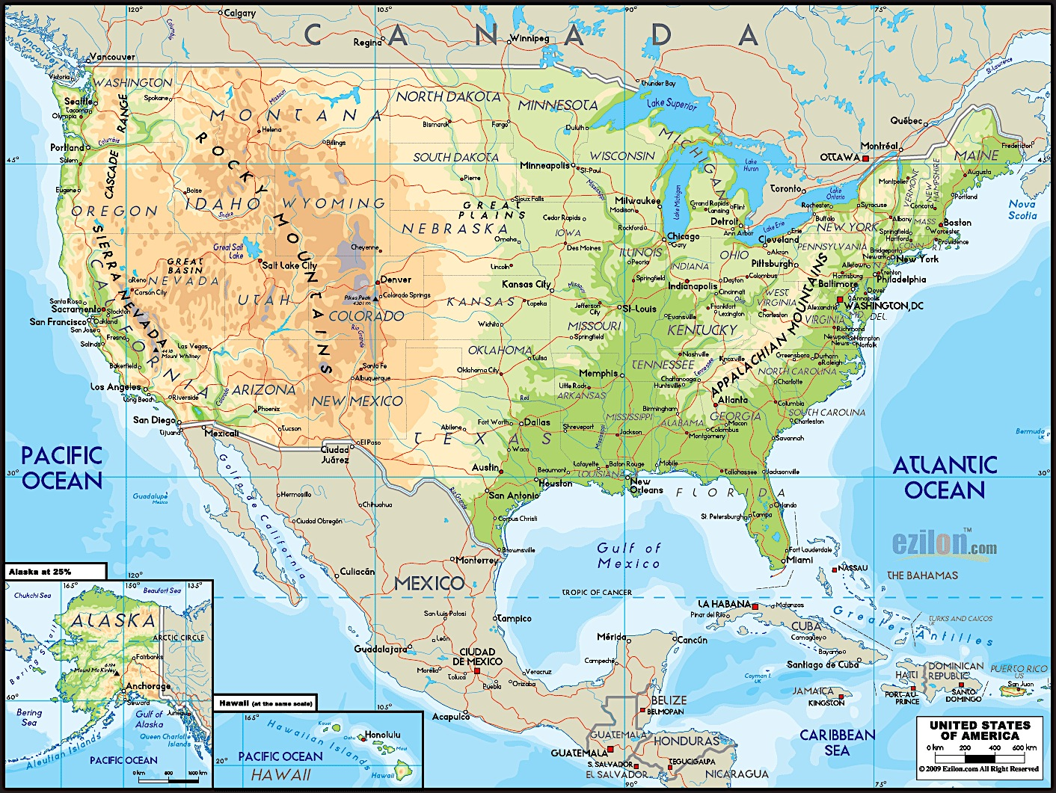

According to the geopolitical consultancy, Stratfor, the United States has five geopolitical imperatives to ensure that it is able to retain its independence and capacity to dominate global affairs:
- Dominate the Greater Mississippi Basin. The Mississippi basin essentially has provided the economic core of the U.S. because of its huge farmland and massive navigable water system, both unequalled in the world.
- Eliminate All Land-Based Threats. This entailed ensuring that neither Canada nor Mexico could or would not pose a threat. It has been achieved largely because of the inherent geographic weaknesses of both countries.
- Control Ocean Approaches to North America: This has been accomplished through building up a substantial navy and by gaining control over Alaska and Hawaii, and de facto control over most of the Caribbean, Cuba being the exception, which explains the obsession with Castro.
- Control the World’s Oceans, which enables the U.S. to dominate the global system both militarily and economically, imposing its will where necessary, including over Middle East oil and all other key resources required for economic development.
- Prevent any serious competitor from arising: The main threat would come from any nation able to dominate Eurasia, as Napoleonic France, Nazi Germany and the Soviet Union attempted to do. The integration of Eurasia into a single political union (not necessarily a single country) would be a threat to the U.S. Such a union would have massive economic potential and would likely control global oil supply. Both China and Russia, possibly in alliance with any of India, Germany, Iran and Turkey could create long-term problems for the U.S.

- The biggest risk to U.S. power in the world is probably the U.S. itself. Its fiscal position, its political gridlock and its recent wars all limit its capacity to act. In all likelihood, we are entering a period, maybe the next 20 years, in which the U.S. is able to protect its core interests but unable to prevent alliances and systems forming which, in the long run, may threaten its hegemony and even its primacy.

- Regional powers are likely to rise, including Brazil, Iran, Germany, Turkey, China, India and Russia, each of which will be somewhat resistant to U.S. power because of their rising economic strength and geographic position. The combination of these in some form of “alliance of the rest” could change the game, but likely not until the 2020s.

Could you see a world in which various other countries prevent the U.S. and its corporations from dominating the world?

Another point of view

- A state-based analysis of global affairs is passé. The real issues are multilateral – the environment, global security, global economic management. The U.S. needs to see itself as a facilitator of the global system, bringing others of various persuasions on board to positively deal with global problems. Do what the UN is unable to do. Abandon its hegemonic stance so that gradually the U.S. gets trusted as a facilitator rather than pursuing self-interest.

- While this may seem idealistic, it is possibly far more in the U.S.’s interests than a strategy based on overt self-interest.

Should/could the U.S. become a multilateral facilitator rather than a “superpower?”
Does the U.S. have a logical defence strategy?

- The U.S. spends about $850 billion annually on defence and homeland security – more than the next 10 nations’ combined defence spending. Yet, the case can be made that no U.S. military endeavour has achieved the desired political objectives since World War II.

- Increasingly, even the military objectives of campaigns are not really being achieved beyond the initial “shock and awe” phase. See Iraq and Afghanistan.

- The U.S. has perhaps the most “powerful” military in world history, with 700 bases around the world, weapon and technology far superior to everyone else’s, including aircraft carriers, missiles, nuclear warheads, aircraft, drones and robots.

- Yet, as one might expect for an organization as large at the Defence Department, the wastage and mistakes are huge – weapon systems such as the F35 aircraft, that never really work as intended.

- The military-industrial complex is going strong. Companies like Lockheed-Martin, Northrop-Grumman, Boeing, General Dynamics, Raytheon, General Electric, Honeywell, Hewlett-Packard…..the list goes on. These are amongst the largest U.S. corporations, and are critically reliant on defence spending.

- The U.S. defence department has talked for at least a decade about becoming a more nimble, agile, flexible organization… good luck with that. The kinds of changes would include a large cutback in foreign bases so that the U.S. military is largely home-based and able to deploy as needed; an dramatic reduction in the capacity to fight land wars; cut back on the number of aircraft carriers from the current 10 active carriers to some lesser number; dramatically reduce the size of its nuclear war capability.

- Even senior people in the military are questioning whether military capability is really the key to securing America’s long-term security, as opposed to investments in education, innovation, infrastructure and diplomacy.

- The U.S. is reaching a stage where it is starting to realize that choices have to be made – domestic and foreign policy/defence programs cannot be viewed separately. The country needs and integrated set of strategic priorities. However, there are extremely powerful interests, including the defence industry lobby that will try and kill this kind of thinking.

- The U.S. is far from the stage of “Imperial Overstretch” in that, at 5% of GDP, defence spending is not about to bring down the country financially. However, a reallocation of half the U.S. defence budget would fund many extremely important non-defence initiatives in areas critically important to the U.S.’s future.

- Even if one looks at defense itself, the question is whether the U.S. is focusing adequately on the threats of the future, particularly cyber warfare.

- Any material reduction in the U.S Defence budget or even any significant change in how the U.S. goes about its defence would require not just overcoming self-interested parties’ objections, but a fundamental rethink of America’s role in the world and how it engages with the rest of the world.

Would a significant reduction in U.S. military spending represent evidence of the country’s decline or the opposite, a recognition that its best interests are served by a different strategic approach?

Session 5: Terrorism; The Middle East

What are the underlying causes of terrorism?

- Keep in mind that “terrorism” is in the eye of the beholder. Nelson Mandela was at one time considered a terrorist. He advocated and carried out violence against random targets. Today he is a revered freedom fighter.

- Terrorism has several putative causes:
  - Straight ideology, such as belief in one political system versus another. Without some other factor at play, this is increasingly rare, although in India, for example, there is Maoist terrorism (the Naxalites) who believe that the Indian state is being "run by a collaboration of imperialists, the comprador bourgeoisie and feudal lords." In 2006, Prime Minister Manmohan Singh referred to the Naxalites as "the single biggest internal security challenge" for India. Other ideologically driven terrorist situations are Luminoso Sendero in Peru and FARC in Colombia.
  - Religion. This is more a factor. At present, it is primarily fundamental Islam that is seen as the source of religion-based terror, but in Northern Ireland it was Catholics against Protestants and in pre-Israel Palestine, it was the Jewish Stern gang. In most cases, religion is a key but not sole factor. What looks like religion-based motivation is often a struggle for land.
  - Oppression. “Terrorism” is often a response to actual or perceived oppression. In South Africa’s case, it was the main factor. During Africa’s de-colonization era, various terrorist groups were fighting for national political freedom. The Kurds in Turkey are another example. In the case of Islamic terrorism in Russia, perceived oppression is also at play.
  - Crime. In some cases terrorism is a front for crime, particularly drug, arms and human trafficking. This is particularly true of FARC. In some cases crime gets mixed in with ideology or other factors as a source of financing.

- The other factor that comes into play is the belief that terrorism can achieve its political objectives. This is where the battle for hearts and minds comes into play.

- One thing that can be said about terrorism with certainty is that it is a tactic of the weak in situations where there are no other outlets for their concerns. That being said, terrorism has generally only achieved political objectives by raising awareness rather than through the violence itself.

Is terrorism a legitimate tactic to achieve change?

Is terrorism a geopolitical issue?

- The geographic spread of global terrorism is wide – China, India, the Middle East, Turkey, the Caucasus region of Russia, Central Asia, North Africa and the Sahel, Nigeria, Colombia and Peru. There have been recent isolated incidents in developed countries such as Norway and the U.S.

- The countries with the most terrorism related fatalities in an average year are Iraq (1798), Pakistan (1468), Yemen (454), Nigeria (437) and India (402). The number of fatalities in developed countries since 9/11 has been negligible, other than the 2005 bombings in the U.K., the 2004 bombings in Spain and the Norway event in 2012.

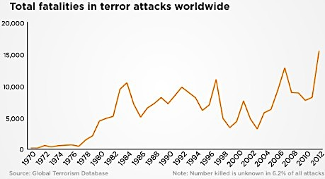

- Most terrorism has been the result of religious sectarianism within Muslim countries such as Iraq and Pakistan. Al Qaeda has been active in a number of countries, particularly in Africa, but this is acknowledge to be the efforts of Al Qaeda-inspired “branches” rather than any central Al Qaeda organization.

- Total global fatalities from terrorism have ranged from about 5,000 to about 15,000 annually. Fatalities increased markedly in Iraq after the departure of U.S. troops and there has been a spike in several African countries. These are generally countries where there is a sharp divide between the Christian and Muslim population, such as in Nigeria, the central African Republic and Sudan.

- There are two distinct narratives about terrorism:
  - It is a global phenomenon driven by Islamic fundamentalists worldwide, particularly Al Qaeda. Their goal is the conversion of a number of states into Islamic states, which are adhere to strict Islamic conservatism and are run according to Sharia law. According to this narrative, the actions against Western states are intended to scare them into staying out of Muslim countries rather than attempting to overthrow Western countries. In Western countries with significant Muslim populations, the goal is to allow Muslims to function according to Sharia law, effectively outside the jurisdiction of the state.

  - Guido Steinberg, a German analyst, presents a perspective very different from the above. His basic argument is that the recent focus of Islamist terrorists on U.S. and European targets -- rather than, say, Saudi Arabian and Egyptian ones -- is a response to Western overreaction to 9/11. The idea of a global struggle waged against the “far enemy” was a minority view within jihadist movements until the United States launched its invasions of Afghanistan and Iraq. One piece of evidence Steinberg points to is that in Europe, most jihadist attacks have targeted countries that participated in those U.S.-led wars, such as Germany, Spain, and the United Kingdom. This well-documented alternative view is widely held in Europe.

Is global terrorism a geopolitical issue or mostly a localized struggle between competing visions of society within particular countries? Was the Global War on Terror Justified?

The Middle East and North Africa

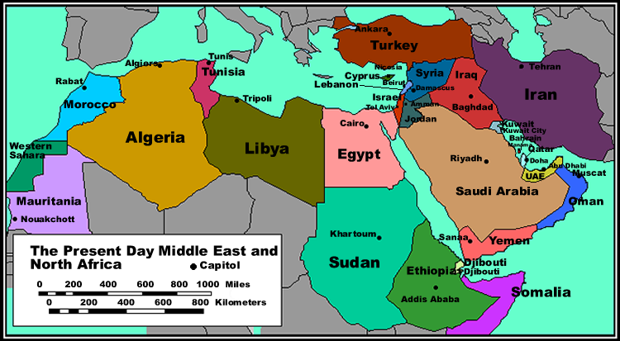

- Geographically, the Middle East has long been an important bridge linking Europe, Africa and Asia.
  - Throughout history, culture, trade, and ideas have flowed through the Middle East “crossroads”. The region was also the domain of many great empires throughout the centuries
  - The Ottoman Empire was one of the most powerful empires in history, lasting over 600 years. The Empire was geographically centered in the Middle East and North Africa (MENA) and Asia

- After the breakup of the Ottoman Empire, The Middle East was colonialized by Britain, France and Russia. As in the case of Africa, artificial boundaries were drawn.

- The area has enormous strategic value because of its geographic location, the Suez Canal and oil. Saudi Arabia in particular, but also the Gulf States, have been under a U.S. security umbrella since WWII, and Israel has special status as a U.S. protectorate.

- Between 1920 and 1960, most countries achieved independence. Ethnic and religious groups were sometimes split up or grouped into borders with historical foes, such as in Syria, and in Iraq. Entire nations, such as the Kurds were left stateless.

- Political development was hampered due to:
  - Too much power in the ‘executive branch’ of the government
  - Autocratic leadership set up or supported by colonial powers
  - Ethnic and religious rivalries
  - Made worse by colonial “divide and rule”
  - The male-dominated cultures of certain tribes and nations
  - Absence of strong civil society to keep political power in check
  - Ongoing meddling by the U.S. and the Soviet Union/Russia

- Oil has enabled autocratic MENA regimes to stay in power, with the tacit support of the West and Soviet Union. This has broken down with the 2011 Arab Spring.

- The other key geopolitical event was the failed invasion of Iraq, unleashing previously contained sectarian rivalries.

Is the Middle East’ situation primarily a function of religion, culture colonization, oil or lack of democratic heritage?

The Emerging Situation

- The region is going through a period of chaos, with a Sunni-Shia struggle for power alongside a push for freedom from autocracy. The West initially supported the freedom movements but has been unable to deal with the fallout. Its position has been first to protect its oil supply and to try and limit outright chaos and expanded war.

- The Syrian war is a proxy fight between various factions, particularly Saudi Arabia and Iran.

- New “Blocs” are forming in the region. Saudi Arabia, the Gulf States and Jordan are acting as a bloc to attempt to have Assad defeated and to reduce the influence of Iran, which has increased since the Iraq War. This bloc also successfully worked to remove Morsi from power in Egypt. This bloc seeks to redraw the map of the Arab Middle East, effectively creating a single integrated political alliance stretching from Morocco to the Iraq border, and with a strong alliance with the U.S. This bloc would be a strong check on Iran whose power has increased with the Iraq war.

- Iran, Assad and Hezbollah are also a bloc. Iraq is de facto part of this group with its Shia majority. Iran is clearly the “spoiler” in the vision of an integrated Sunni-dominated Middle East.

- Egypt, Libya and Tunisia are largely non-players due to their instability. Algeria and Morocco are peripheral geographically and also are relatively poor.

- The wild card in this formation is Turkey, which, as a Sunni nation, would normally align with the Sunni countries, and it is actively anti-Assad. However, there are signs of a Turkey-Iran rapprochement, which would have immense significance in the region. If Iran and Turkey should decide to form a bloc of some kind, the Middle East would have two strong opposing blocs, with a risk of a bigger conflict than the one in Syria.

- The U.S. is gradually disengaging from the region as it becomes less dependent on its oil. While it still supports the Saudi and Gulf regimes, it will not allow them to pursue radical Sunni jihadists in the Middle East, Pakistan, the Caucasus and Central Asia.

- It is likely that the only way the Syrian War could be brought to a swift conclusion would be if Turkey and Iran, with U.S. and Russian support in the background, jointly decide that this should happen. Unfortunately, the Ukrainian situation will prevent any cooperation between the U.S. and Russia.

- The next step in stabilizing the region would be for Iran to stop supporting Hezbollah and Hamas in return for re-acceptance into the global community, and in return for Israel’s signing of the Nuclear non-proliferation treaty and its withdrawal from at least some West Bank settlements

- In summary, a huge amount hangs on the negotiations to bring Iran in as a constructive player, reducing rather than increasing tensions in the region, helping bring about the end of Syrian war and helping bring about an Israeli-Palestinian settlement. Iran, Turkey, Saudi Arabia and the Gulf states are the main players. The U.S. and Russia are the main external influencers.

Can the U.S. bring about a grand Middle Eastern bargain between the main parties? Will Russia support this?

Session 6: Surveillance and Cybersecurity; Emerging Players

The Snowden effect, whistleblowing sees a sharp rise

The question at the end of the first of 3 cases is whether you can see internet controls, or even increased transparency, dampening the rise in whistleblowing.

- There has been a huge increase in whistleblowing in the US. The SEC received 3,238 tip-offs in the past year, with 12% coming from abroad, according to global investigations by Kroll the year saw a 25% increase in tip-offs from foreign countries.

- A 35% increase in the number of cases reported by whistleblowers to the U.K.'s Financial Conduct Authority (FCA), from 3,813 to 5,150 also occurred. Canada is home to the second largest number of overseas whistleblowers with 62 tip-offs, 15% of all those from outside the US, China with 52 tip-offs follows is third, Russia & India make the remaining top five.

- A whistleblower was involved in 1 in 3 incidents of all cases where fraud was uncovered and in a staggering 41% of cases that involved senior or middle management. As companies increasingly invest in often risky emerging markets and more stringent regulation and guidance governing whistleblowing procedures is introduced, cases of whistleblowing will continue to rise.

- Financial rewards and protection help the process. Whistleblowers have cashed in on payouts from the SEC in the last fiscal year, with one being awarded $14 million under the U.S.'s Dodd Frank Act, which gives protection to those who expose misconduct.

- The U.K. authorities are considering offering rewards to whistleblowers, as a very effective way of discovering fraud. Increased overseas whistleblower tip-offs to the SEC show the policy's impact on international companies in particular. Those thinking about reporting corporate malpractice might be tempted to go to the U.S. regulator rather than their own company, wherever they are based in the world, in the hope of receiving a substantial reward.

Can you see internet controls or even increased transparency dampening the rise in whistleblowing?

The second case deals with whether Snowden deserves applause or clemency.

Snowden: the case for prosecution - Treachery and its consequences
- Mr. Snowden has done some good, he has highlighted the NSA’s sloppy security procedures and the danger of “contractorisation”. He stoked a necessary debate on the nature of meta-data and has shown that using legal means to arm-twist internet and technology companies into cooperating with the NSA can backfire.

- But these benefits are far outweighed by the harm, a few examples of exposures:
  - How the NSA intercepts e-mails, phone calls and radio transmissions of Taliban fighters in Pakistan and it’s operation to gauge loyalties of CIA recruits in Pakistan
  - E-mail intercepts regarding Iran
  - Global tracking of cell-phone calls to look for unknown associates of known intelligence targets by tracking people whose movements intersect
  - Hacking into computers and mobile phones in China and Hong Kong

- It is a useful question to ask what Mr. Snowden should have done to be judged a genuine whistle-blower. One condition is that he should have come across activity that was actually illegal (he didn’t: he saw stuff he didn’t like, and worried about where it was heading).

- He should have exhausted all available legal and constitutional options (he didn’t). The information he published should have been collected and distributed in a way that did the least damage for the desired effect (it wasn’t; he stole a colossal number of documents, mostly quite unrelated to the points he wanted to make, and their release is accompanied by colossal spin and considerable inaccuracy).

- His fugitive status in Russia (via Hong Kong) could hardly be designed to cause more alarm among those who care about American & allied secrets. In short, neither the problems he has uncovered, nor the means he has chosen, give Mr. Snowden or his defenders any reason to expect that their law-breaking should be treated mildly.

Do you agree that Snowden deserves neither applause nor clemency?

The third case is that the EU should get some major show of goodwill from the US in upcoming trade agreements. I’ll ask at the end if you agree with this statement.

US Spying is a 'Slap in the Face': says EU Lawmaker
- The EU has to respond pretty robustly to the Americans' activities. European leaders warned that the alleged bugging could derail major trade talks, with France's President Francois Hollande saying that Europe would hold off on any negotiations until it was sure the U.S. spying had ended.

- The EU has made big efforts to get these talks underway and they feel extremely let down by the Americans. It does undermine confidence in each other's negotiating position and trust.

- Reports by The Guardian newspaper & Germany's Der Spiegel, claimed the National Security Agency (NSA) had run an extensive program to spy on the EU representative's office in Washington as well as the EU office to the United Nations in New York. Der Spiegel also reported one spying operation had targeted an office that housed the EU Council of Ministers in Brussels.

- Another member of the European Parliament told CNBC that the U.S.-EU trade talks are now likely to be delayed, adding that when they do occur, the spying allegations would be the elephant in the room. We would need some major show of goodwill from the US, Sharon Bowles, the chair of the European Parliament's Economic and Monetary Affairs Committee said.

- It's just going to be there in the back of your mind; did they listen in? Do they have an unfair advantage? Do they know all our strategies? Even though I'm sure they'll tell us that the bugging is all to do with security. The U.S. spying allegations appeared to be part of a recurring theme, just saying Whoops! Sorry and it won't happen again, is not really going to be enough.

- Fears that the pact could open up fiercer competition in areas such as agricultural goods and the film industry have previously been discussed, with France threatening to veto certain sectors from any agreement.

Do you agree that the EU should get some major show of goodwill from the US in upcoming trade agreements? Would this effect Canada?

The Emerging Players on the Global Scene

Are emerging countries really reshaping world power?

- The first group of emerging countries to be recognized as a power group were the “BRICs” – Brazil, Russia, India and China, later with South Africa added. This is a highly disparate group. South Africa does not belong as it is too small and has weak economic growth. Russia was already a power. China and India were the main story, with China by far the more important. Brazil is also important regionally and possibly beyond.

World’s Top 20 Economies

 | GDP $Tn PPP  2012 | 2050  Rank | GDP $Tn  PPP 2050 Forecast. | Pop.  Millions 2014 | Pop.  Millions  2050 Fcst. | Median Age  2013
1. U.S. | 16.2 | 2. | 38.0 | 317.8 | 361.7 | 36.9
2. China | 12.3 | 1. | 53.9 | 1,364 | 1,393.1 | 35.2
3. India | 4.7 | 3. | 34.7 | 1,243 | 1,523.5 | 25.9
4. Japan | 4.6 | 5. | 8.1 | 127.1 | 108.3 | 44.6
5. Germany | 3.2 | 9. | 5.8 | 80.7 | 72.6 | 43.7
6. Russia | 2.5 | 6. | 8.0 | 146.0 | 136.4 | 38.5
7. Brazil | 2.3 | 4. | 8.8 | 201.0 | 220.5 | 30.5
8. UK | 2.3 | 11. | 5.6 | 63.7 | 73.1 | 40.5
9. France | 2.2 | 10. | 5.7 | 65.9 | 73.2 | 39.7
10. Italy | 1.8 | 13. | 3.9 | 60.0 | 60.0 | 44.3
11. Mexico | 1.8 | 7. | 7.4 | 119.7 | 135.4 | 26.7
12. S.Korea | 1.6 | 15. | 3.5 | 50.2 | 51.0 | 37.9
13. Canada | 1.5 | 16. | 3.5 | 35.3 | 45.2 | 40.7
14. Spain | 1.4 | 14. | 3.6 | 46.6 | 48.2 | 41.5
15. Indones | 1.2 | 8. | 6.3 | 247.4 | 279.7 | 27.9
16. Turkey | 1.1 | 12. | 5.0 | 76.7 | 94.6 | 28.1
17. Iran | 1.0 | 19 | 3.0 | 77.3 | 105.5 | 27.6
18. Austral. | 1.0 | - | 1.5 | 23.4 | 33.7 | 37.5
19. Saudi | 0.9 | 18. | 3.1 | 30.0 | 40.4 | 21.6
20. Taiwan | 0.9 | _ | 1.4 | 23.4 | 25.0 | 37.0

- The above table shows a dramatic economic and population realignment. By 2050 China’s economy will be larger than that of the U.S. Brazil, Russia, Mexico and Indonesia will have surpassed not only Canada, Spain and Italy, but also Britain France and Germany. Nigeria and Vietnam will have joined the top 20.

Do population and economic strength determine geopolitical power? Are emerging countries going to become more powerful in global affairs?
The BRICs

- The China story is astonishing as we have already discussed. There can be no debate about a power shift to China even though it has not yet sought to fundamentally change the world order. China has massive influence in Africa, Central Asia and will soon in Latin America and the Middle East. Increasingly, no major global decision can be reached without China’s involvement.

- The India story is more nuanced. It has 17% of the world’s population and its economy is third largest, although only about one third that of China. Its economic growth is slower and more domestic, so it is not a great trading nation. It is mainly a regional player with modest global influence. Demographically, India has a huge advantage over China, having a median age of 25.9, compared with China’s 35.2. India’s political institutions are weak and it is far from a united country. Its infrastructure is poor and it is not making the necessary investments to improve it. It has an ongoing conflict with Pakistan and rivalry with China, causing it to divert significant resources to its military. However, all that being said, India is likely to be a power this century because of its massive population, favourable demographics and increasing literacy rate. Productivity improvements will likely enable it to be an economic powerhouse and have matching political clout.

- Brazil has a population of 200 million, by far the largest in Latin America and is massive in size, 4th largest in the world. It has huge resources, including recently discovered oil. Its population is relatively young and its institutions and infrastructure are increasingly strong. It is diverse, does not invest heavily in military and has no enemies. It has a corruption problem that has held it back, but by any reckoning Brazil will be one of the top 10 world powers this century. It is emerging as one of the key nodes of the “global south”, playing an important role in international affairs with other global south countries around the U.S. and Europe. Brazil needs to strengthen its institutions, and alleviate poverty and inequality to make the most of its human capital.

Will China, Brazil and India become major global powers changing the whole geopolitical balance? What could prevent this?
The Next Group

- The next emerging players are debatable, but most agree that they include Mexico, Turkey, Indonesia and Nigeria. All of these countries have large, young populations, and are close to major markets. They are also strategically located from a geopolitical point of view

Mexico

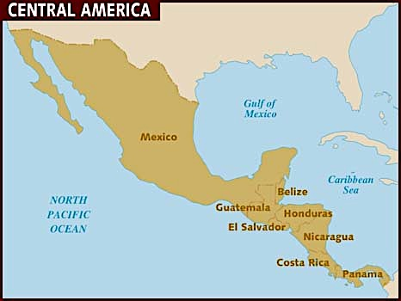

- Mexico’s economy is already integrated into that of the U.S. It is seen as an attractive alternative manufacturing location to China and other distant countries. It has a stable political system and it has large oil resources, so far not well developed, but now increasingly open to foreign investment which will increase production. Mexico, along with Brazil, is a gateway into Latin America and is well positioned to be the regional leader. Its advantage is that its language is Spanish. Mexico has a drug crime problem and this is holding it back, but if it can get this under control it will emerge more strongly. It is not likely to become a global power as it is too small relative to others and its location next to the U.S. will prevent it from becoming too strong, but like Brazil, it will wield regional influence and be an important “global south” player.

Turkey

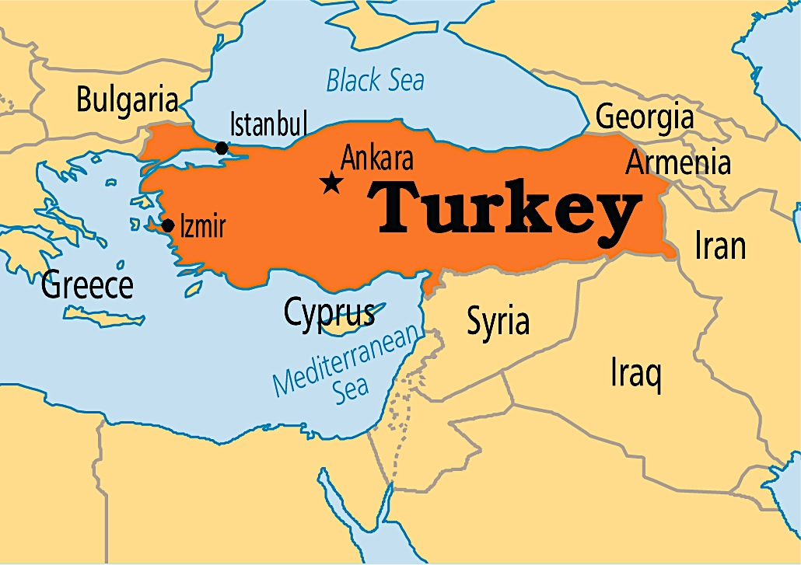

- Turkey has a more important geopolitical role than Mexico. It has emerged as the most stable democracy in the Middle East and will be a power broker in that region. Further, it is likely to extend its influence into the Caucasus and Central Asia as the natural leader of the Turkic peoples who populate a huge swath from Turkey to Western China, including the Uighurs in Xinjiang, China. Turkey could be a powerful player integrating and stabilizing this important region. Turkey is also positioned as a natural producer for Europe, and the major gas pipelines that are an alternative energy source for Europe run through Turkey. It has recently discovered its own large shale gas deposits in the Eastern Mediterranean. It has largely made peace with its Kurdish minority, and while it is run somewhat autocratically at present, it is a functioning democracy. It is probably the most strategically-located country in the world, with access to three continents, a huge coast –line and it bridges at least three civilizations. In the 21st century, Turkey is likely to emerge as one of a handful of global power players.

Indonesia

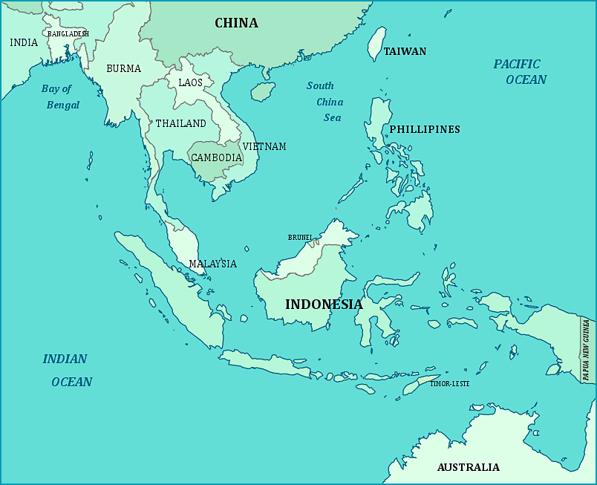

- Indonesia is another strategically located country. It dominates the trade routes from East Asia to Europe and is itself within 2,500 miles, less than NY-LA, of more than half the world’s population. It is the world’s 5th most populous country and is young. It has significant oil, natural gas and coal reserves, giving it economic strength. It has a relatively weak infrastructure and institutions but these are improving. It does have serious environmental challenges – flooding, drought, earthquakes. It is a functioning democracy after decades of autocratic rule. It has no natural enemies. While it is predominantly Muslim and has harboured terrorists, it has defeated them for the present. Jakarta, although it has difficulties, is emerging as one of the largest and most interesting cities in the world. Indonesia is not likely to become a major geopolitical player due to its proximity to China and India, but it could emerge as a leader of the South-East Asian bloc, an important grouping. Tensions in the South China Sea between China and some ASEAN nations are a concern. Indonesia should be a stabilizing influence.

Nigeria
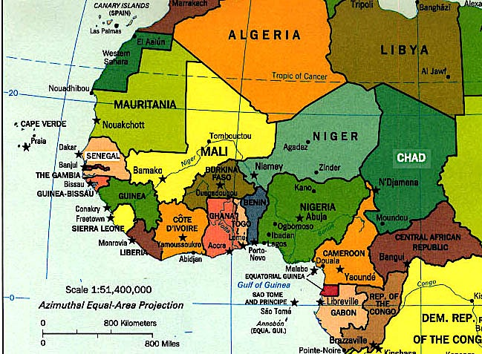

- Nigeria is another matter entirely. It is already the 7th most populous country in the world with 173 million people, and by far the most populous in Africa. It is projected to have a population of 440 million in 2050 and 913 million by 2100, in both cases making it the 3rd most populous nation. Economically, it is now the largest in Africa, having overtaken South Africa. Nigeria is one of the major oil exporting countries, giving it strong foreign exchange earnings, but this has given rise to the “oil curse”. Also, oil revenues have benefited mainly the southeast of the country and the Igbo tribal grouping, and also only an elite. The main fracture within the country is between Muslim and Christian, and there is active ethnic rivalry as well as Al Qaeda-inspired terrorism by the Boko Haram group. Thus Nigeria has serious problems with tribalism, religious differences, terrorism and also endemic corruption, making it one of the most difficult to govern countries. However it is a massive market and it will inevitably be the dominant player in Sub-Saharan Africa, which will have a population of 2 billion by 2050 and almost 4 billion by 2100. Nigeria is positioned to be a huge beneficiary of this population growth, but will need itself to become governable and stable first. There is no doubt that the major powers will seek to have influence in Nigeria, and it could become one of the sites of contestation between the U.S. and China in this century.

Which of these countries will be politically powerful in 2030?
Session 7: Global Governance. What it Means to Us

What do we mean by “global governance” and why do we need it?

- Global governance is the means by which decisions that affect several countries are reached and implemented, where there is no overarching political authority. You can think of global governance, therefore, as "the management of global processes in the absence of global government”.
- Think of everything a government does – security, regulation of health, economic management, energy and environmental policy – and take that up to managing these issues on a global or regional level. Add in that there is no regional or global government (other than a few cases such as the EU), and you get the need for “governance”, a broader term than government.

- There are hundreds if not thousands of organizations engaged in global governance of some kind, but the major ones are:
  - The UN and it many agencies – UNEP, WHO, UNESCO, UNHCR, ILO
  - The G-8 – whatever it wants to do
  - The G-20 – mainly economic focus
  - The IMF and World Bank – all about finance
  - The World Trade Organization – trade
  - Regional organizations – OAS, ASEAN, EU
  - The International Criminal Court and the International Court for Justice

- Some of these organizations are general purpose (UN, G-8) while others are specialized (WTO, WHO, ICC/ICJ). Most are formal bodies with legal constitutions (UN), while others are informal networks (G-8, G-20).

- Globalization over the last 25 years in particular, has dramatically increased the intensity of cross border activity of all kinds – economic, social, cultural, political, crime, terrorism and more. This has increased the need for governance beyond state borders.

- The other key dimension of global governance is that it is, in effect, an alternative to geopolitics, or at least an alternative way of doing geopolitics. Traditionally, geopolitics has been about raw power and the use of military might to exert this power. Global governance is about “multilateralism”, namely solving problems in global forums according to international law and norms rather than individual action by countries, such as the U.S. action in Iraq or Russia’s in Ukraine.

- Both of these actions elicited deep concern by the international community because they take us back to an era of might is right. Like it or not, Israel’s actions in the West Bank create similar concerns.

- Some global governance is required to deal with global technical matters. An obvious example is the setting of rules for international civil aviation. Our world would not function without these. We take them for granted today, but they are a classic case of many parties, governments, professional bodies, airlines, aircraft manufacturers and others, getting together to craft rules and to update them on an ongoing basis.
- A concern expressed by some is that our nations states give up some sovereignty when they empower global governance. For example by signing the World Trade Organization agreement we give up rights of governments to “buy domestic” and governments can be sued by corporations to prevent this.

- Despite concerns about loss of state sovereignty, many commentators believe that the framework of global governance is seriously inadequate to address the transnational problems of today. The lack of ability to rein in global banks is cited as an example, as is the inability to reach agreement on climate change.

Overall are you in favour of broader, deeper and more formalized global governance, or less handing over of state sovereignty to unelected global bodies

The Evolution of Global Governance

- There are several schools of thought about how global governance should work:
  - Institutional – formal institutions such as the UN, IMF etc.
  - Transnational: Institutions, but other players as well – NGOs, corporations, social movements, even hyper-empowered individuals
  - Hegemonic: One or a few major powers call the shots and force decisions
  - Cosmopolitanism: The “global community” of individuals converges around key issues and effectively force their governments to act – gay marriage, assisted suicide, women’s rights, environmentalism etc.

- These are not mutually exclusive, but transnationalism and cosmopolitanism are replacing institutional and hegemonic approaches, partially due to the internet. A good example was the campaign to ban anti-personnel landmines.

Can we move to a world based on international law and norms and a global approach to problem solving? Will the big powers ever agree to be bound by this? Will their populations force them to do so or the reverse?

What Does This All Mean to Us?

- Can we be insulated from the economic shift to the East and South? Is it in fact good for us?

- Is increasing inequality in almost every society sustainable and what could it result in? What will it mean in Canada?

- Should we be worried about global demographic trends – 9.5 billion people by 2050, an ageing developed world, an exploding African population?

- Is ubiquitous surveillance something we will just have to live with?

- Is cyber-warfare the next kind of conflict and what could it mean to us?

- Can we in Canada wean ourselves off fossil fuels and will we be prepared to pay more for energy to do so? Or will we just try and adapt to increasing climactic disasters?

- Can countries like Russia be accommodated within the global system or does Russia have to change?

- Other effects on our world?

